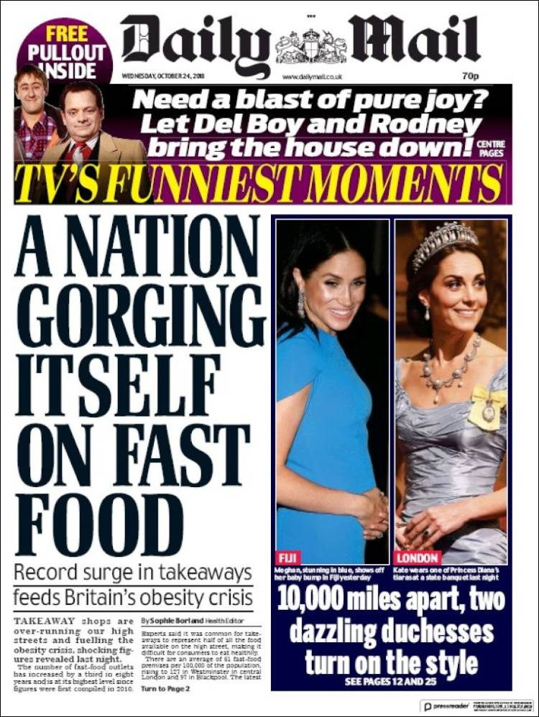

SECTION A:GENERAL QUESTIONS (REFER TO YOUR NOTES)
- Who is the new editor of the Daily Mail?
- How has the tone of the newspaper changed since the last editor Paul Dacre was in charge?
- Who owns the Daily Mail? What is its political affiliation? Comment on this.
- Why is issue of newspaper ownership important?
(section total: 7 marks)

SECTION B: THIS FRONT PAGE
- Comment on the following codes and conventions:
- Main headline
- Main image
- The banner advert
- Jumpline
- Masthead and crest
(section total: 5 marks)

SECTION C A-LEVEL STYLE QUESTIONS (Don’t worry about repeating parts of your answers in each one)

- Discuss the representation of women on this page. How does it fit in with ideas of patriarchy? Link with Berger and/or Mulvey’s ideas about female
- Do Moral Panics (Stanley Cohen) feature in any way on this page?
- How do the stories highlight social division and inequality? Discuss the use of binary opposites and the effect on readers.
- Is there a link between some of these stories and Dyer’s Utopian Solutions Model.
- What is the possible general effect of these media stories on readers? – make a link with the Hypodermic Needle Model.
- Why do you think tabloid front pages tend to avoid ‘hard news’ (e.g. war, explosions, accidents, attacks, ongoing tragedies and misfortune)? Why is there often a link with the world of TV and showbiz celebrity?

(Section total: 18 marks)

